Your server is successfully set up.

Finally, open the new host in your browser.

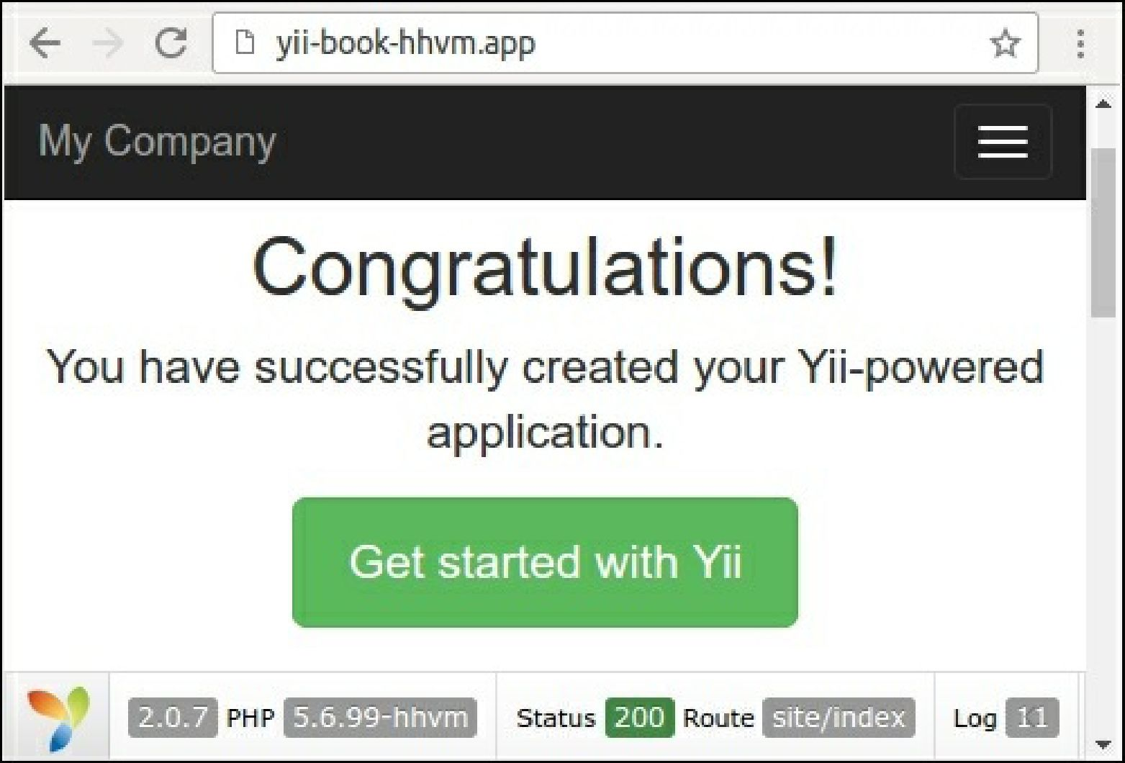

How it works...

You can use HHVM as an alternative PHP process in the fastcgi mode. By default, it listens to the 9000 port. You can change the default port of the fastcgi process in the /etc/hhvm/server. ini file:

**hhvm.server.port = 9000**

Configure the specific PHP options in the /etc/hhvm/php.ini file.

See also

For more information about installing HHVM, refer to the following URLs:

* <https://docs.hhvm.com/hhvm/installation/linux>
* <https://docs.hhvm.com/hhvm/installation/mac>

In order to learn more information about HHVM usage refer to <https://docs.hhvm.com/hhvm/>.